* Administrador de Obra , instead of Administrator obra **FIXED**
* When you login every profile shows the same, each one needs to show their role as the subtitile
* **FIXED**

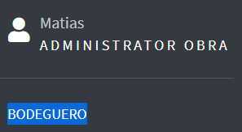

* When you press the titile construapp it shows the not found message **FIXED** 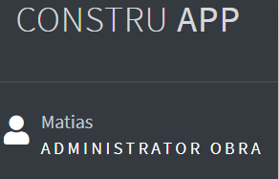

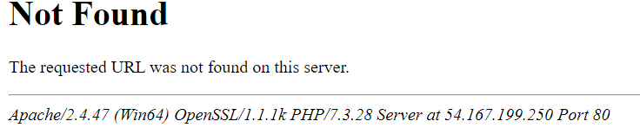

* Units of quantity allows to write letters (needs to be just numbers) **FIXED**

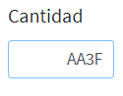

Module Bodega:

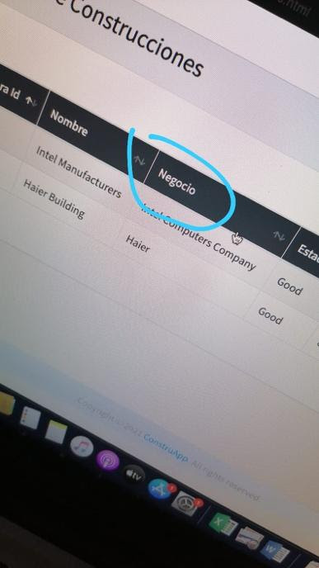

instead of negocio use -> : “MANDANTE PROYECTO “ **FIXED**

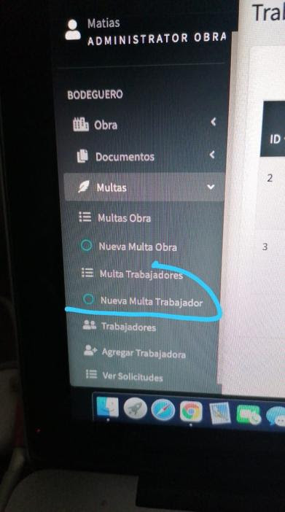

instead of multa trabajadores use -> “AMONESTACIONES TRABAJADORES” **FIXED**

instead of nueva multa trabajadores use -> “NUEVA AMONESTACION DE TRABAJADOR”

**FIXED**

AGREGAR TRABAJORA –> AGREGAR TRABAJADOR/A **FIXED**

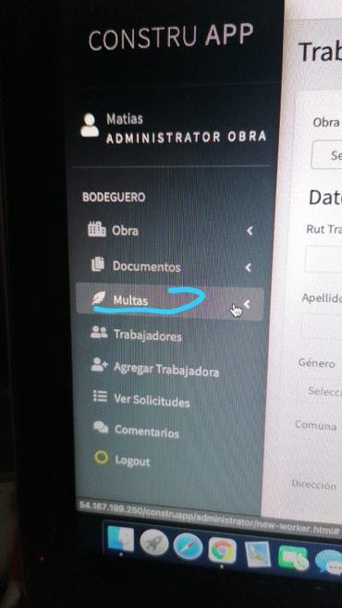

MULTAS –> MULTAS Y AMONESTACIONES **FIXED**

MATERIALS -> MATERIALES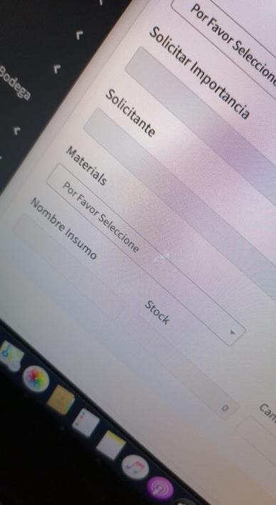

**FIXED**

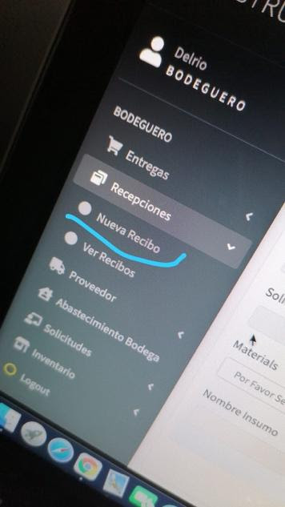

NUEVA RECIBO -> NUEVO RECIBO  **FIXED**

**FIXED**

MATERIALS -> MATERIALES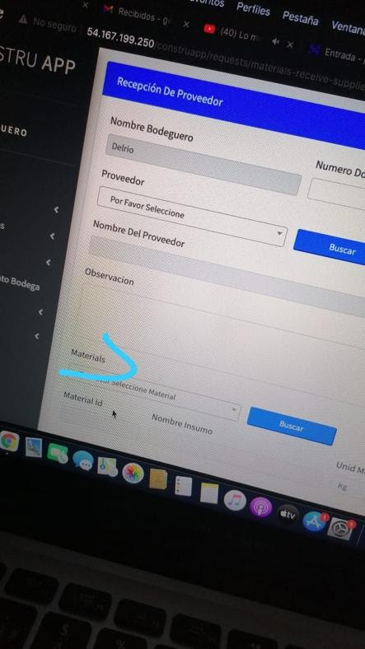

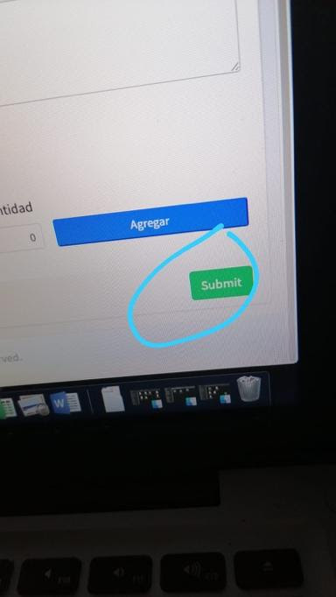

SUBMIT -> ENVIAR

**FIXED**

RESET -> RESETEAR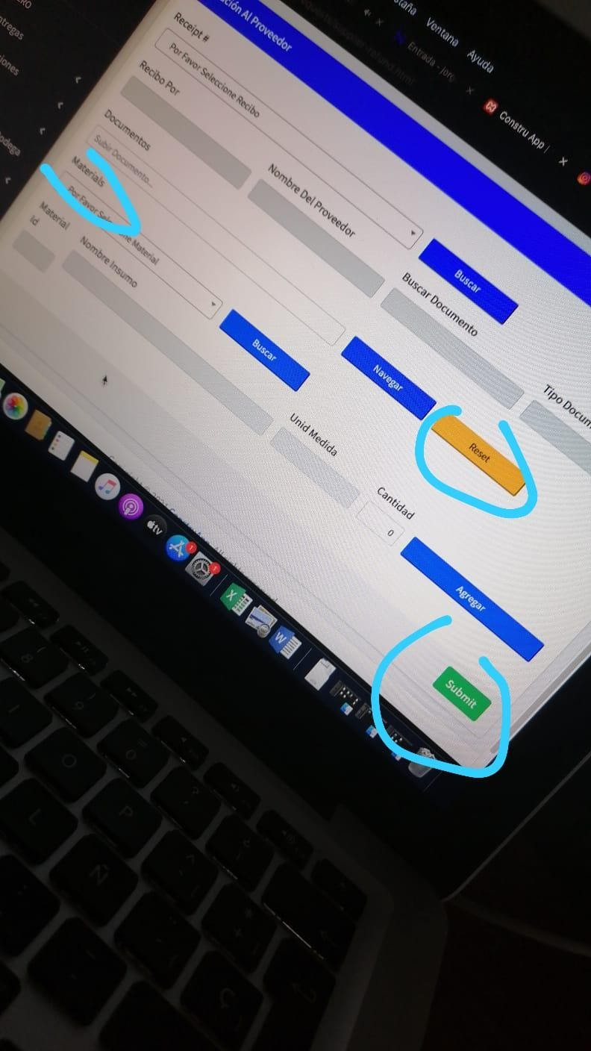

SUBMIT -> ENVIAR

MATERIALS -> MATERIALES

**FIXED**

C-INSUMO separated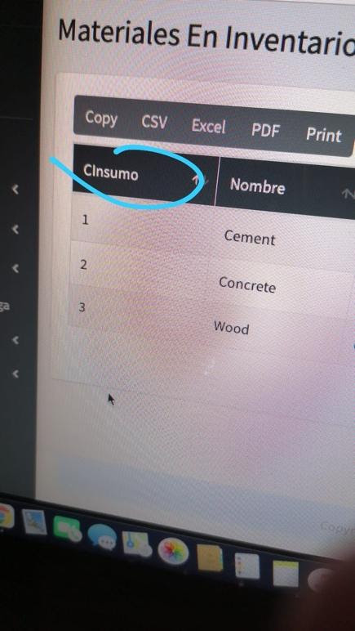

**FIXED**

    MATERIALES Y HERRAMIENTAS EN INVENTARIO .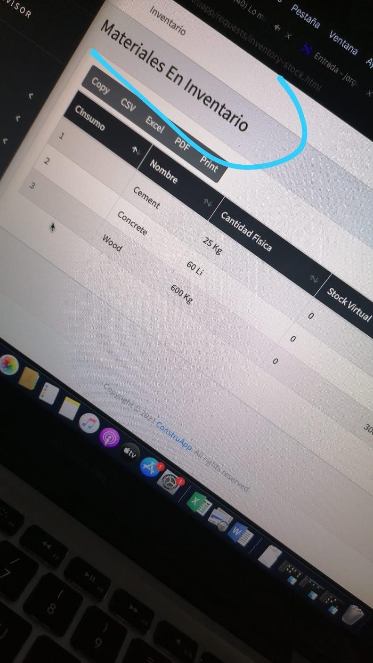

**FIXED**

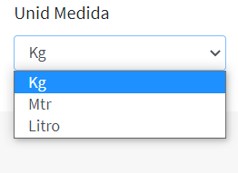

Change Mtr -> Mt

change Litro -> L

**FIXED**

There are no restrictions on the boxes, you can write texts with all existing characters

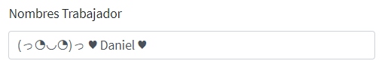

**FIXED**

After registering the user with the name that is seen in the image, when seeing the registration of the workers, it appeared as follows:

https://lh3.googleusercontent.com/l-zo0YTQ3jPIKphUaJZKzWKBSst2ZUDKkp5oPZqkVnIk-btyeO4Qs1y5YgYIcdS3KtQVex2wU7ZBiOyINubzCtLeHBhTZvh_1wgDdyTDuBURZZKWakiezA_GXlHLO9OGLb5TzYiJ=s0

At the moment of dragging the pointer towards the menu, the options on the screen do not adapt, but the options menu covers and on top of the page. Ideally, the boxes should move when the menu is displayed.

Dear Sir,

At the moment of dragging the pointer towards the menu, the options on the screen do not adapt, but the options menu covers and on top of the page.

You are right Sir but you should press the same button again which you used to push menu on left. ( the three lines on top left).

Ideally, the boxes should move when the menu is displayed.

The boxes move sir but not on pointer over event because if we do this then whenever cursor moves over menu the screen will get small then large on mouse exit so it’s not recommended. If you want that effect you should use same button you’ll see the effect. Thanks

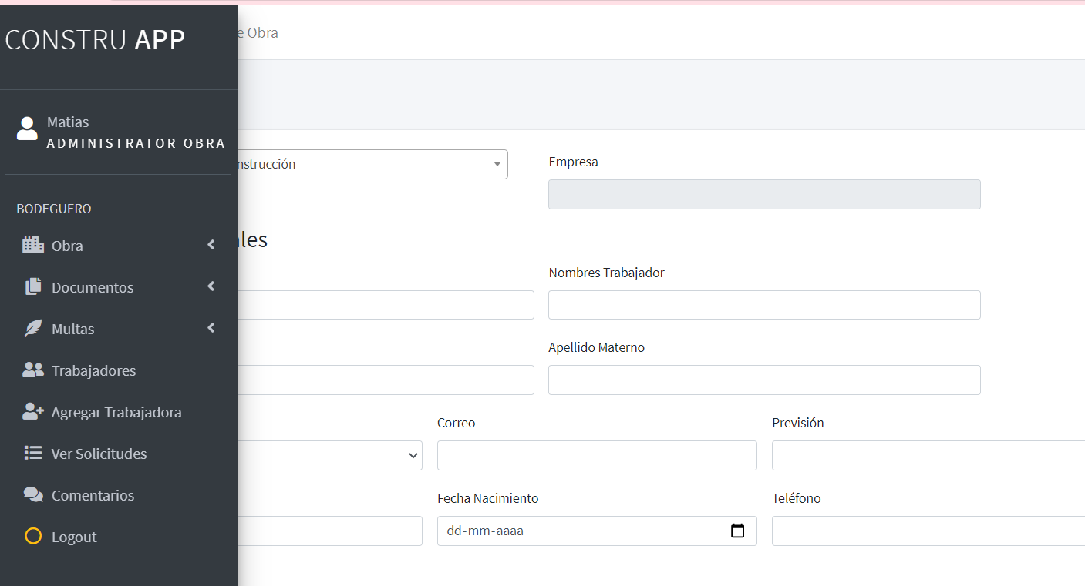

**Role Administrador de obra / Supervisor:**

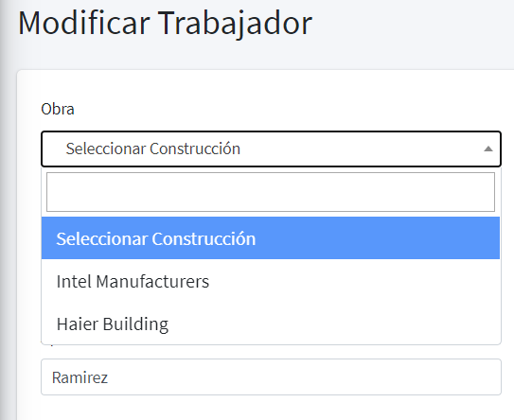

When selecting the option "Select construction" and saving data it does not show us a message showing the reason why it does not allow us to save the data, as a suggestion to add a validation that says " ".

Sorry Sir I did not understood you point. Please explain



In the option to see requests when pressing the eye, it shows us the following error:

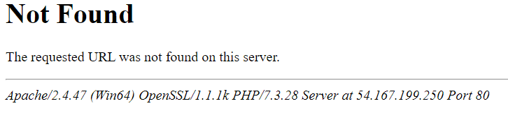

The supervisor role has the same options as the works administrator, in the documentation different functions are specified.

I Know sir the restrictions are not imposed now, that will be there once we have all available modules developed. Then the sidebar menu is now static. This would be generated based on user role and the modules assigned to that user this part comes later when administrator will assign each user there modules and delete or edit that hope you understood.

Text boxes that should be numbers only allow any character.

I’ve done this but I’ll review in detail too.

**Role Bodeguero:**

In the part of requests shows the following box, we found that the text “escriba paises aqui" did not have coherence with materials.

FIXED

Also make sure that says Materiales instead of materials

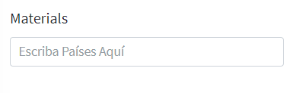

change “decha” -> “Fecha”

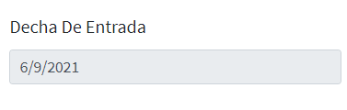

When supplying the Bodega, the following error appears on the screen:

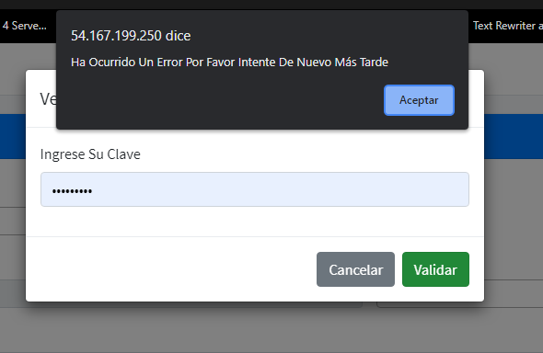

At the moment of clicking "Ver recibos" it does not show anything, but at the moment of clicking the option "Nuevo recibo" it shows the following error:

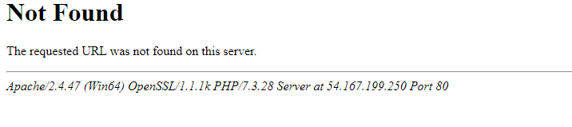

make sure that says NUEVO RECIBO

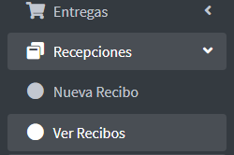

Materials request simulation:

Here we can see how a request for two materials is created

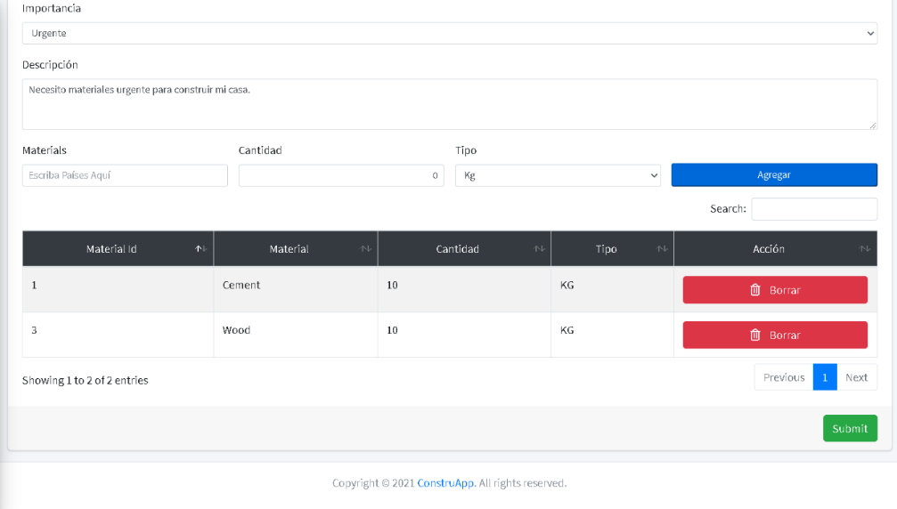

2- In this capture the request has been sent successfully.

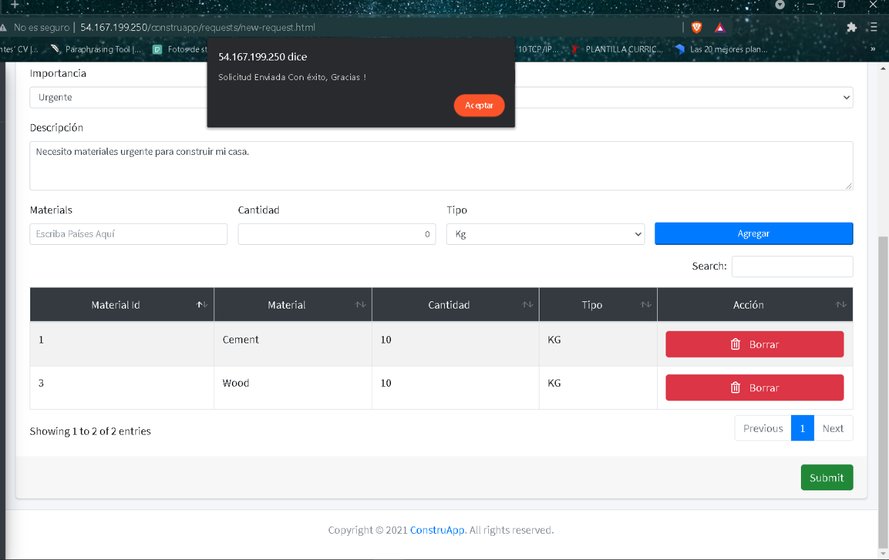

3- When trying to view the request, it is not registered in the table

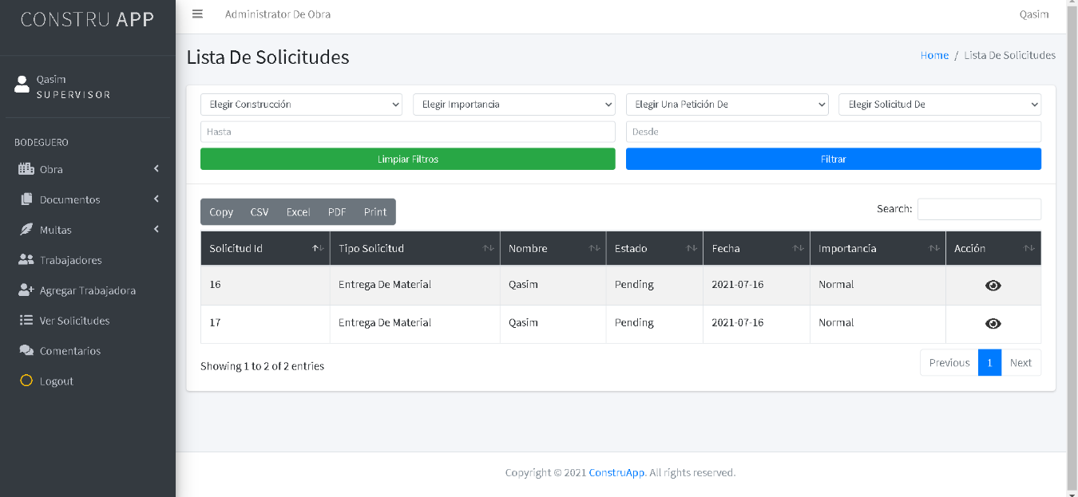

I’ve checked the database and your request is there. Maybe you was logged in from a different user so you was not able to view the request.

A user with bodeguero role can see only his requests which are added by him.

A user with role Supervisor can see requests that are requested to him and he can approve or reject that.

The pages which says not found should be there that’s why I’ve added them in the sidebar but they are not developed because the pdfs sent to me don’t include that. Don’t worry I’ll develop that for you but just let me know if you need that or not.

Thank you. Please focus on language and the modules check if all modules are there that are required and also they have the proper fields too. Don’t worry about the restrictions.

Once again thank you hope this is clear. I’m working on barcode you can send me next module too if you want once I’m done with barcode. I’ll start working on module.